**Aim: To develop a method to calculate motion-inclusive dose in Pinnacle TPS**

**1. Concept**: KIM provides motion information of the tumour volume. A Pinnacle script is used to calculate the motion encoded dose. For each sub-beam in an arc, the target shift is modeled by a corresponding isocentre shift (Fig. 1). Dose calculation is resulted in motion including target dose distributions. The concept is similar as in Ref.: Poulsen et al., Med. Phys. 39 (10), 2012.

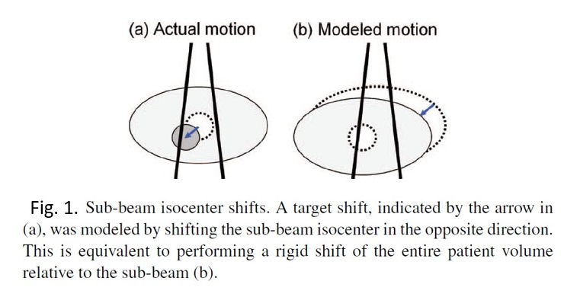

Fig 2. Shows the dose reconstruction workflow.

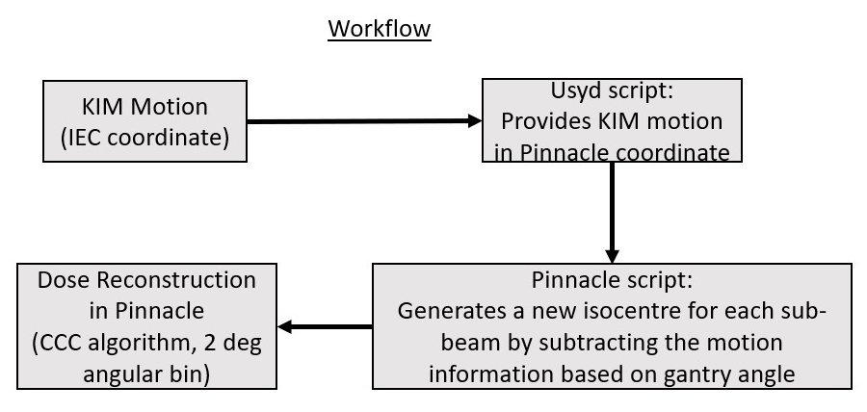

Fig. 2: Motion inclusive dose reconstruction workflow for Pinnacle TPS.

**MATLAB script**: Provides motion information (obtained from KIM) as a function of gantry angle.

**Pinnacle script**: Calculates motion inclusive dose on the Pinnacle TPS.

* 1. **Obtain motion from KIM (MATLAB script):**

- KIM is run as part of the patient treatment

- The code calculates average of the three markers w.r.t. the treatment isocentre using the KIM log files.

- Selects KIM data by removing the constant gantry angles (which may happen when the MV beam was not turned ON).

- Separate data into arcs.

- Subtract 90 deg from KIM angle to provide the MV angle and adds 360 deg to the angles those are less than zero to make sure both conventions are the same.

- Bin data in 2 deg angular bin.

- Transform KIM IEC coordinate to Pinnacle coordinate.

- It generates motion files for arcs (Motion in LR, SI and AP directions as a function of gantry angles) with the Beam name as in the original plan.

- To run this code, one needs MATLAB installed on a computer. The code will need the location of the KIM generated motion files, the patient coordinate file and the start time of each arc. Then click “Run”.

**1.2 Calculate motion inclusive dose (Pinnacle script):**

- It looks through the entire file for each arc and creates the new isocentre based on gantry angles (subtracts the KIM predicted position from the original isocentre).

- If an angle does not exist in the KIM motion file, the code would use the original isocentre.

- The code then calculates dose.

- To run the code, go to Utilities -> Scripting ->Browse->Select the folder (/usr/local/adacnew/PinnacleSiteData/Scripts/LARK_Dose_Recon/ -> Click start.script).

**We will use CCC algorithm and calculate dose in 2 deg angular bin.**

**1.3 Method to calculate dose for a treatment fraction:**

For each treatment fraction,

- **Calculate planned dose**

**- Dose using KIM motion**

**- Simulated dose assuming no tracking**

Each time, one needs to follow the workflow in Fig. 2 to calculate planned dose and motion inclusive doses.

**Planned dose** - Assuming zero motion (original arc split into sub-beams). We may see some disagreement between the dose calculated using the original plan and using the split sub-beam plan. We won’t see this difference if we could separate the KIM data in smaller angular bins, however, the lowest angular bin for dose calculation that can be used in Pinnacle is 2 deg. Hence, a small difference between the original plan and split-beam plan may be seen. We expect that this difference will cancel out as we want to determine the difference between split-beam plan and split-beam tracking DVH and similarly split-beam plan and split-beam no tracking DVH.

**Motion-encoded dose** using the above method for KIM tracking

**Motion-encoded dose** using the above method for simulated no tracking and compare the DVHs.

**2. Tests performed at Nepean to verify the above method:**

Below are the tests that have been performed to verify the consistency of the coordinate systems between Pinnacle and KIM. We compare the split-beam dose against a non-split-beam dose calculation (full arcs).

We used the LARK phantom and recorded the KIM data for no shift and 5/20 mm couch shifts in all directions. We calculated dose using the above method (will be referred as ‘**split-beam dose’**) and compared that with an equivalent shift of the planned isocentre (will be referred as ‘**arc-plan dose**’).

**Objective of the experiment:** The main objective was to:

1. Test the coordinates, i.e., testing that the isodose lines in the split-beam plan shift in the same direction as the arc-plan does when an equivalent shift has been applied.
2. Inspect visually that the arc-plan DVH and split-beam DVH are close. Any quantitative assessment has not been done.

**Passing criteria**: Isodose lines in the split-beam plan shift in the same direction as the arc-plan does and the DVHs are close.

The coordinate transformation relationship is given below:

**x IEC = x Pinnacle**

**y IEC = - z Pinnacle**

**z IEC = y Pinnacle**

Thetrial ‘***Dose_recon***’ refers to ***split-beam dose*** and the trial ‘***2deg Arc***’ refers to ***arc-plan dose***.

**No shift:**

No shift – original plan (look at the orange isodose line in the next page and compare with the same line here and see how that moves.)

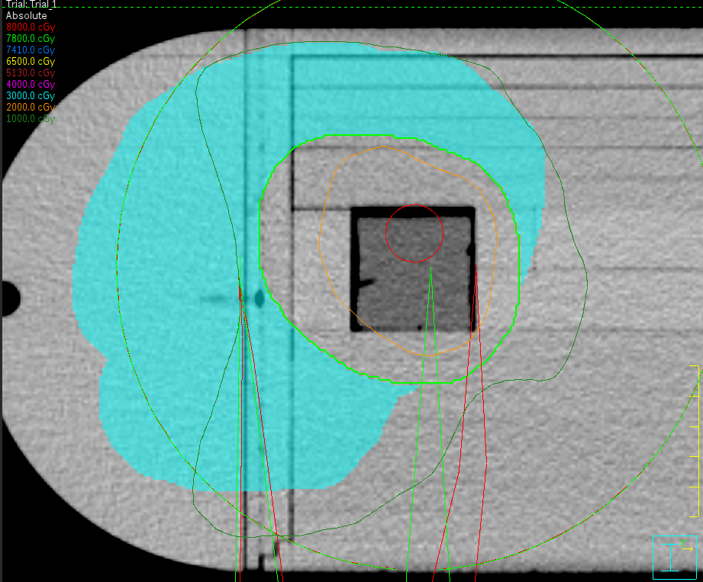

**Motion: y = +5 mm (shifts Pinnacle y isocentre by -5 mm)** – Check the orange line.

**Split-beam dose Arc plan dose**

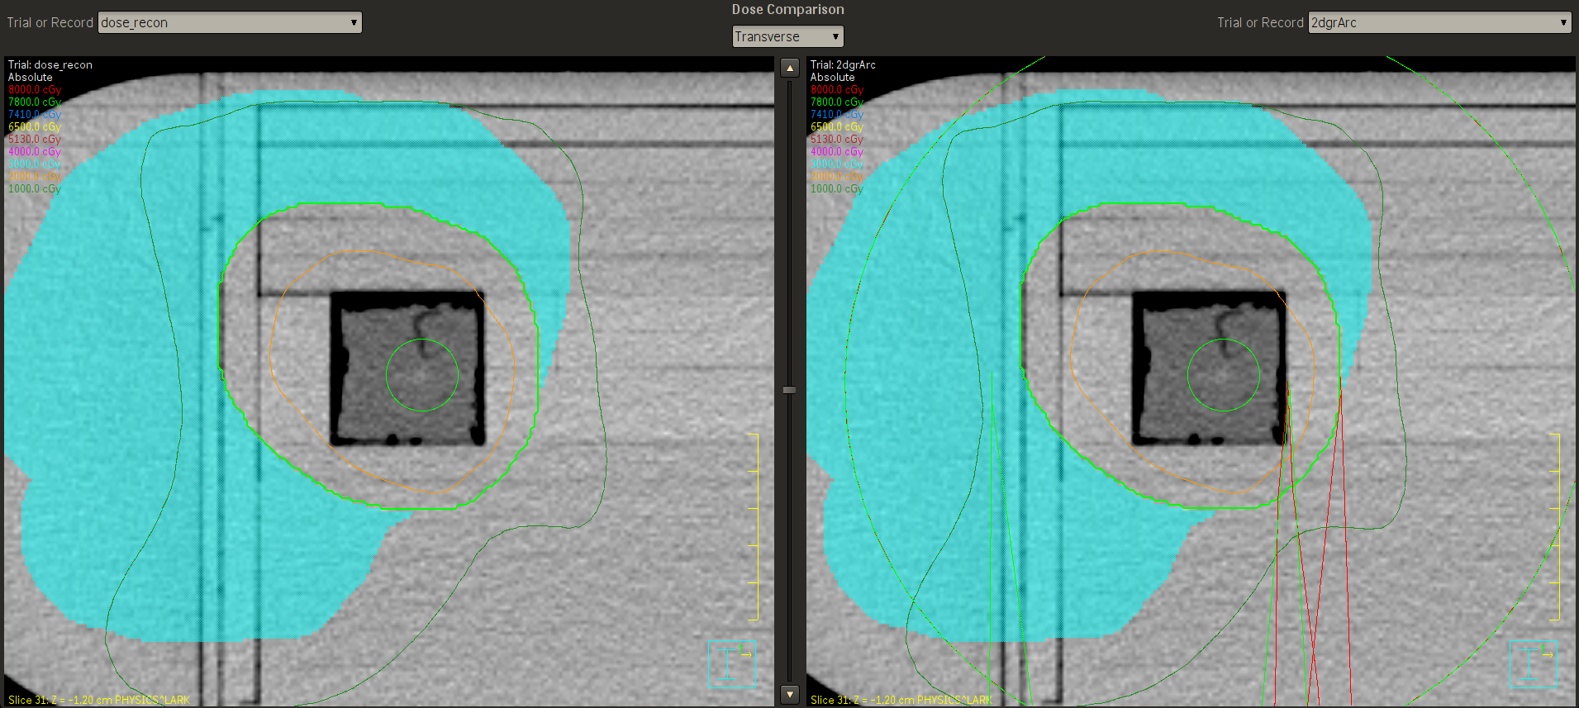

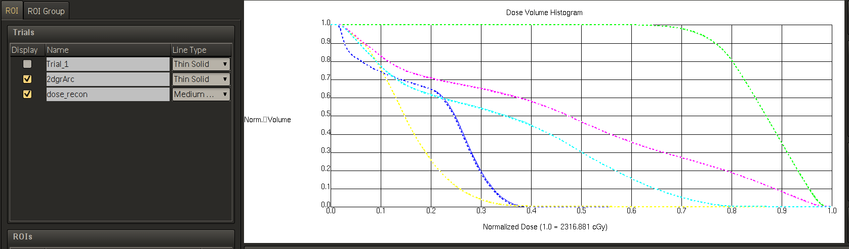

**Motion: y = -5 mm (shifts Pinnacle y isocentre by +5 mm)**

**Split-beam dose Arc plan dose**

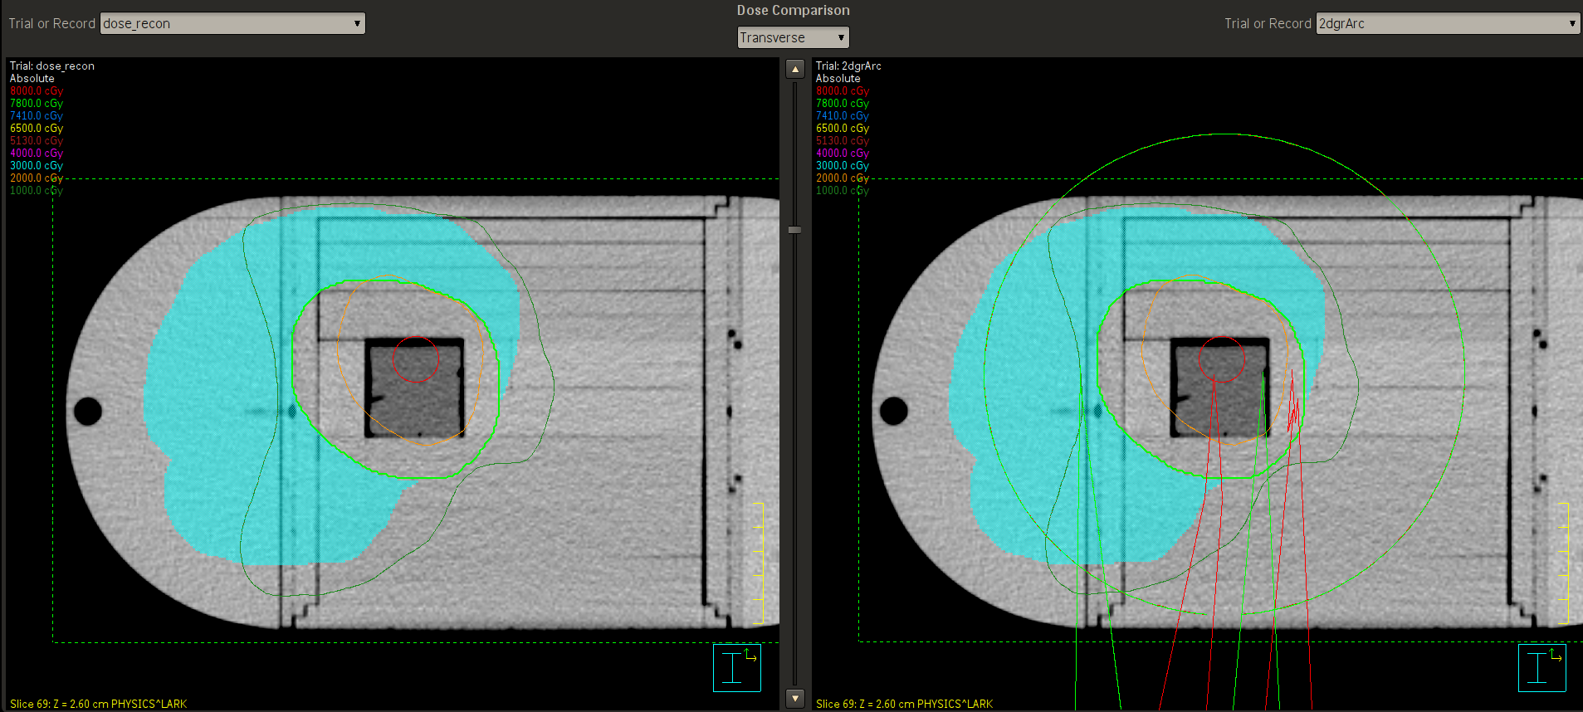

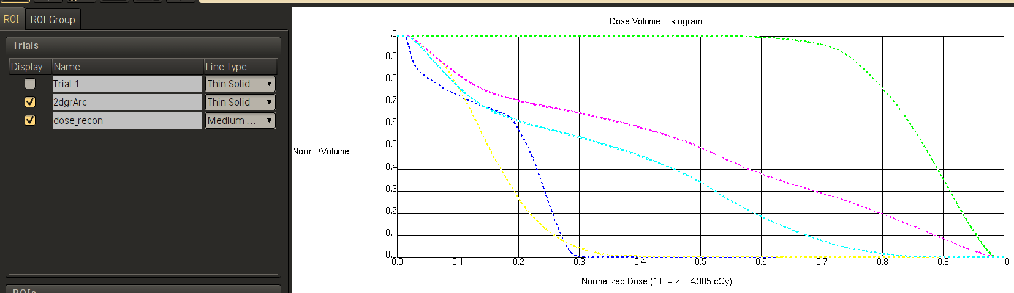

**No shift – original plan – Check the orange isodose line and compare with the one in the next page.**

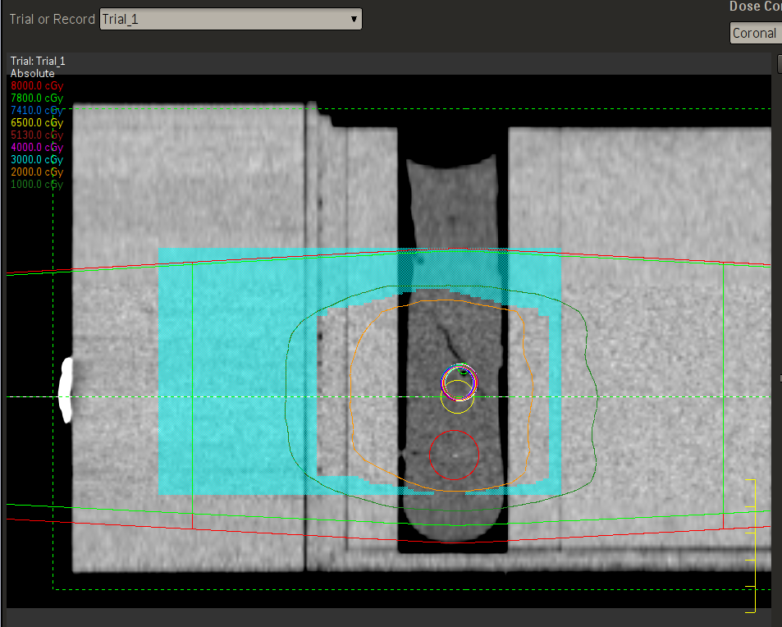

**z = +5 mm (shifts Pinnacle z isocentre by -5 mm)**

**Split-beam dose Arc plan dose**

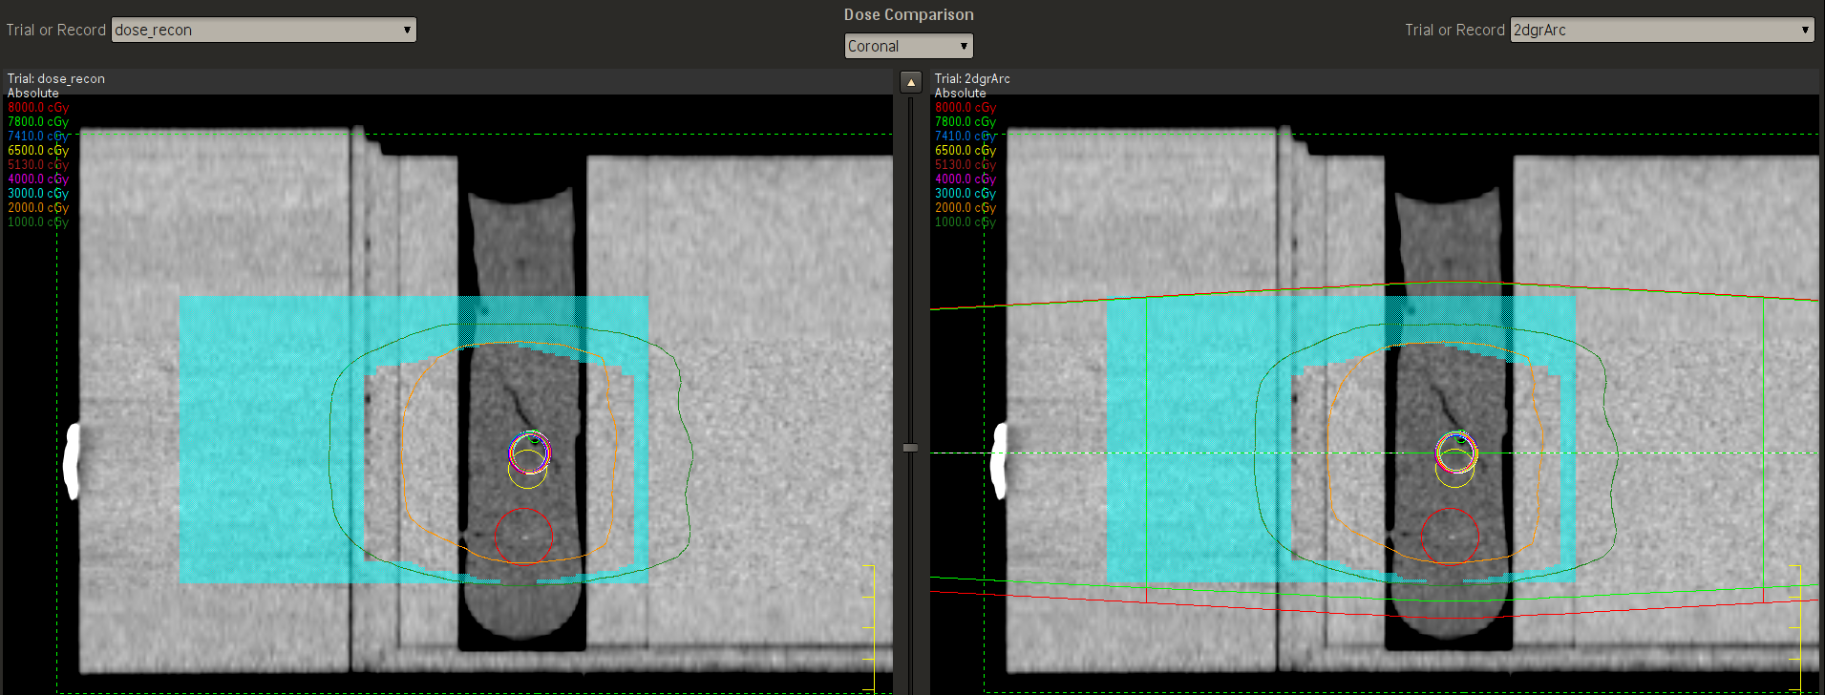

In the DVH, the full line is the original plan.

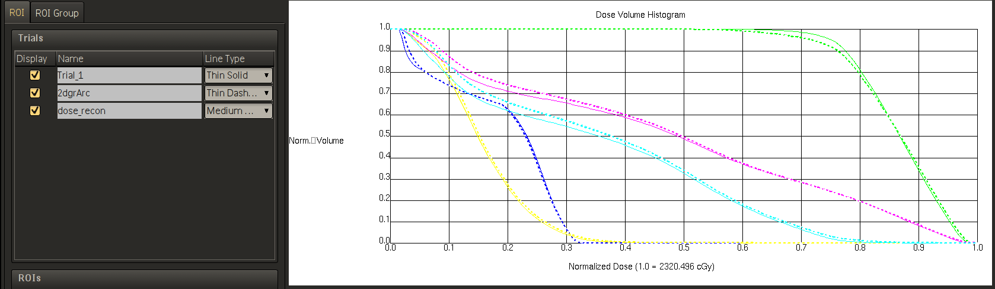

**z = -5 mm (shifts Pinnacle z isocentre by +5 mm)**

**Split-beam dose Arc plan dose**

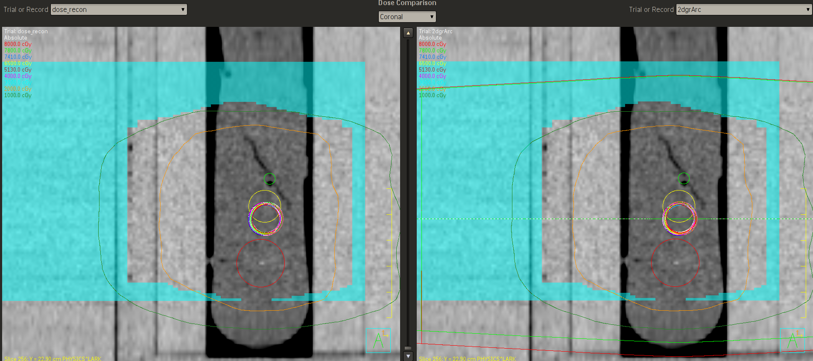

In the DVH, the full line is the original plan.

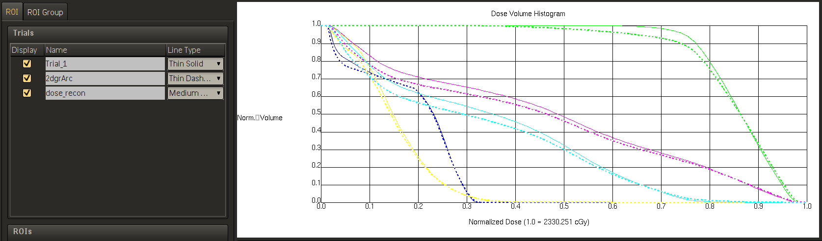

**Original plan – no shift -** Look at the orange isodose line in the next page and compare with the same line here and see how that moves.

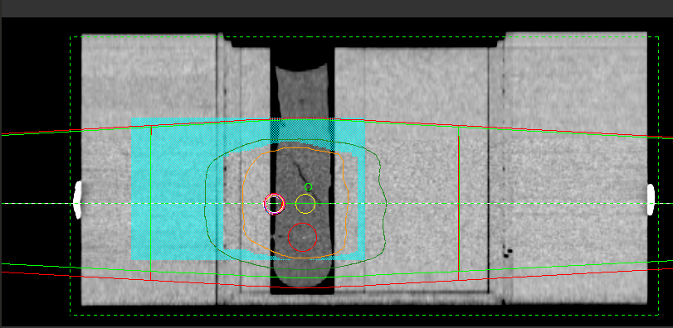

**x = +20 mm (shifts Pinnacle x isocentre by -20 mm)**

**Split-beam dose Arc plan dose**

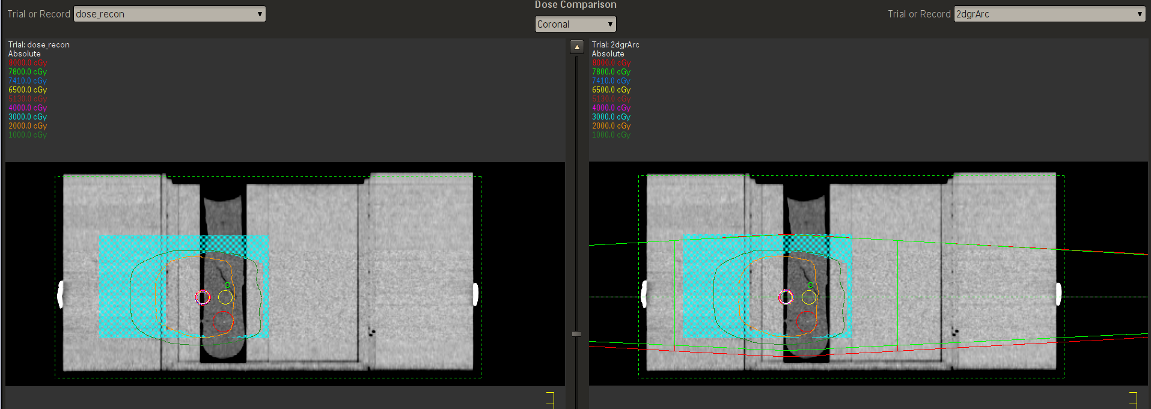

In the DVH, the full line is the original plan.

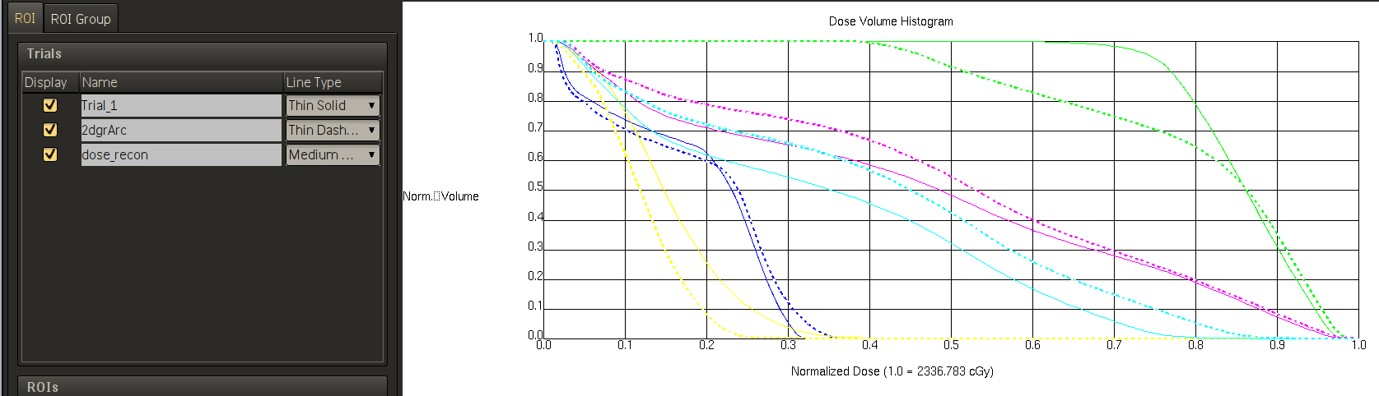

**x = -20 mm (shifts Pinnacle x isocentre by +20 mm)**

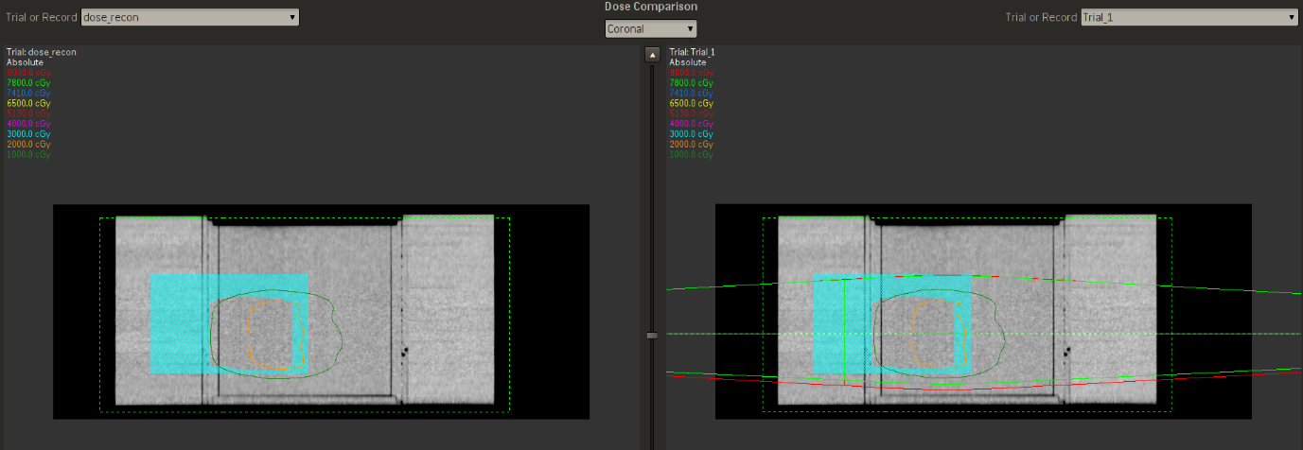**Split-beam dose Arc plan dose**

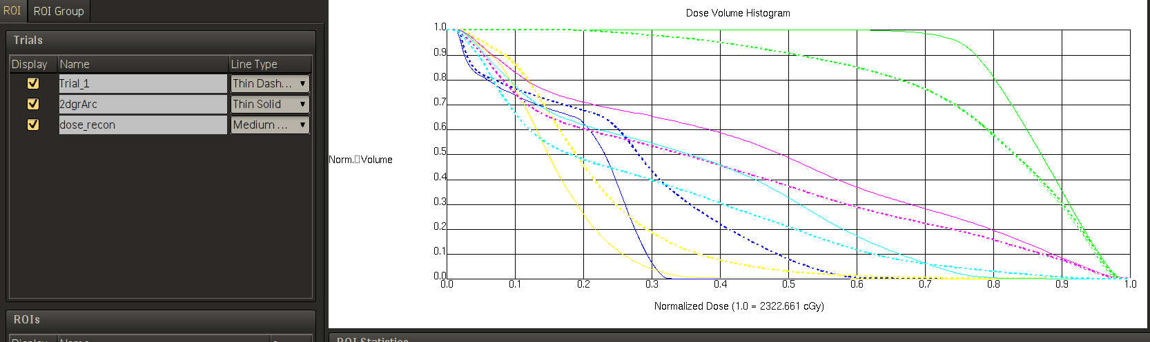

**Conclusion**: The isodose lines of the split-beam plan shift in the correct direction when compared with the original arc plan isocentre shift in all the tests. So the coordinates are correct. The DVHs also look similar when split-beam plan was compared with the original arc plan isocentre shift for all the tests.